Table of Contents

1 SOLID principles. 5

1.1 S - Single Responsibility 5

1.2 O - Open Closed 5

1.3 L - Liskov Substitution 5

1.4 I – Interface Segragation 5

1.5 D -Dependency Inversion 5

2 Design Patterns 5

3 Repository pattern used? 5

4 Dependency Injection 6

5 IOC and DIP 7

6 .net framework and .net core difference 7

7 Versions of software’s evolution 7

7.1 C# Language 7

7.2 .net framework 8

7.3 Asp .net core MVC 8

7.4 MVC 9

7.5 Entity Framework 10

7.6 Angular 11

8 Life cycle of ASP .net MVC application: 11

9 Life cycle of ASP .net Core application: 15

10 Latest C# features: 26

10.1 Async and Await calls, Tuple, pattern matching. 26

11 C# features 26

11.1 Collection 26

11.2 Generics 26

11.3 Delegates 26

11.4 Dictionary 26

11.5 List 26

11.6 Tuple 26

11.7 Serialization 26

11.8 Exception Handling in c# 27

11.9 LINQ (Include and Except) command. 27

12 Thread mechanism. 27

13 Queue 27

14 Seri Log 28

15 WebHooks 28

16 Authentication and Authorisation 28

16.1 - Kerberos for authentication? 28

16.2 - ID server and IDP 28

16.3 - Single Sign On. (SSO) 28

16.4 - OAuth 2 and 1 28

17 Types Of ORM and To use it. 28

18 Entity Framework described 28

18.1 Entity framework commands used in Command Line. 29

18.2 Important Nuget packages to be used. 29

18.3 Fluent API. 29

18.4 Migration and Seeding data to be handled? 29

19 Publishing done 29

19.1 IIS basics and how it is relevant. 29

19.2 Comparing Kestrel Web Server vs IIS 29

20 .net core features explained 30

20.1 Difference between ConfigureService() and Configure() in startup.cs. 30

20.2 Exception handling done? Logging mechanism in .net core.. 30

21 MVC basics and its version. (Kersetrel) 30

21.1 Routing in MVC 30

21.2 Filters in .net 30

21.3 Exception handling done 30

22 Web Api 30

22.1 Web API 2 Parameter Binding 30

22.2 AutoMapper and Helper class 32

22.3 Logging mechanism 32

22.4 Exception Handling done in web api. 32

22.5 Routing in Web Api. 32

22.6 Filters in .net 32

22.7 What is Rest, Web Api and WCF examples. 32

22.8 API basics. 32

22.9 Two factor Authentication. 32

23 Compression techniques? 32

24 Query String, Query Parameter and URL params. 32

25 DI lifetime(Transient, Singleton, Scoped and Transient Inside Singleton) 32

26 Performance monitoring tools in VS. 33

27 Notification methods used: 33

27.1 Rabbit MQ 33

27.2 Signal R. 33

28 Database 33

28.1 Postgres SQL interview questions. 33

28.2 What is NoSQL? 33

28.3 SqlLite use? 33

29 Devops process 33

29.1 DevOps practises. 33

29.2 CI/CD pipelines. 33

30 Tools used for devops 33

30.1 Jira and Confluence 33

30.2 CI/CD pipeline 33

30.3 Cloud 33

30.4 Azure Architecture Framework 33

30.5 Azure questions and uses. 34

30.6 Serverless on Azure 34

30.7 What are the key characteristics exposed by Cloud Computing? 35

30.8 Azure CLI? 35

30.9 Azure Fabric? 35

31 What are Storage keys in Azure? 35

32 Explain what is Federation in SQL Azure? 35

33 Why should you use Azure CDN? 35

34 What are the roles available in Windows Azure? 35

35 What is the use of VNET? 35

36 How Many Types Of Deployment Models Are Used In Cloud? 35

37 What is the difference between Public Cloud and Private Cloud? 35

38 Name the web application types that can be deployed with the Azure? 35

39 Types of services offered in cloud /host web sites in Azure ? IAAS, PAAS, SAAS and Serverless. 35

40 What is Azure Function? 37

41 Azure diagnostics 37

42 What is Blob? 37

43 What is the difference between Block Blob vs Page Blob? 37

44 Scalability of the cloud computing? 37

45 What are the advantages of cloud computing? 37

46 What are the different cloud deployment models? 37

47 Azure Active Directory in cloud, AD(Azure Directory) - In premise. 37

48 AAD, B2B and B2C login. 37

49 Terms to handle 37

49.1 Container 37

49.2 Dockerizing 37

49.3 Yaml 37

49.4 PowerShell 37

49.5 ArmTemplates 37

49.6 Web Hooks 37

50 Microservices. 37

51 Using cloud watch and Azure monitor 38

52 What are the important drawbacks of using Microsoft Azure? 38

53 Common Web techniques 38

53.1 CORS (Cross-origin resource sharing) 38

53.2 SSL certifcate. 39

53.3 Wildcard SSL cert for trlsoftware.com, we have certs for individual subdomains via LetsEncrypt. 39

53.4 What is multi tenancy and how is it achieved? 39

53.5 How to make a site Https? 39

53.6 Nginx, Proxy and Reverse proxy. 39

53.7 Error Codes in server and client side? 39

53.8 Globalisation and localisation 39

53.9 JSON serialisation and Deserialization 40

54 Using Git Bash and other version control mechanism! 40

# SOLID principles.

## S - Single Responsibility

## O - Open Closed

## L - Liskov Substitution

## I – Interface Segragation

## D -Dependency Inversion

# Design Patterns

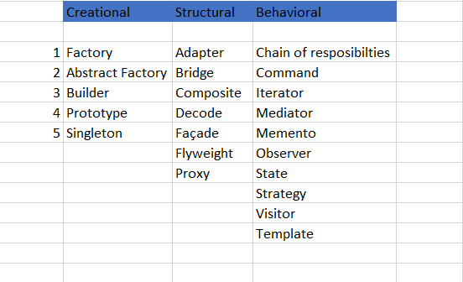

# Repository pattern used?

The Repository pattern implements separation of concerns by abstracting the data persistence logic in your application

The repository and unit of work patterns are intended to create an abstraction layer between the data access layer and the business logic layer of an application. Implementing these patterns can help insulate your application from changes in the data store and can facilitate automated unit testing or test-driven development (TDD).

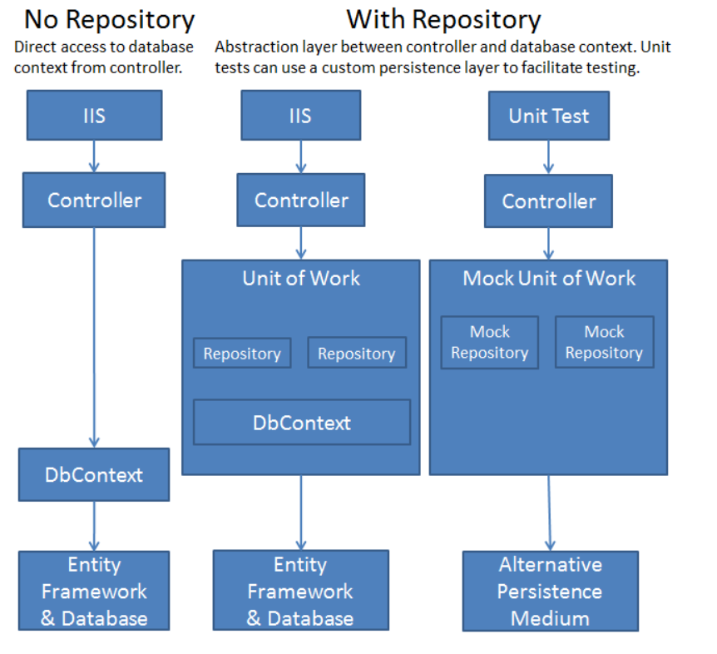

There are various advantages of the Repository Pattern including:

* Business logic can be tested without need for an external source
* Database access logic can be tested separately
* No duplication of code
* Caching strategy for the datasource can be centralized
* Domain driven development is easier
* Centralizing the data access logic, so code maintainability is easier

# Dependency Injection

* **Dependency Injection** (DI) is a software design pattern that allows us to develop loosely coupled code. (used to implement IoC)
* Injector class injects the service (dependency) to the client (dependent).
* Injects dependencies in three ways: through a constructor, property, method.

Constructor Injection: In the constructor injection, the injector supplies the service (dependency) through the client class constructor.

Property Injection: In the property injection (aka the Setter Injection), the injector supplies the dependency through a public property of the client class.

Method Injection: In this type of injection, the client class implements an interface which declares the method(s) to supply the dependency and the injector uses this interface to supply the dependency to the client class.

# IOC and DIP

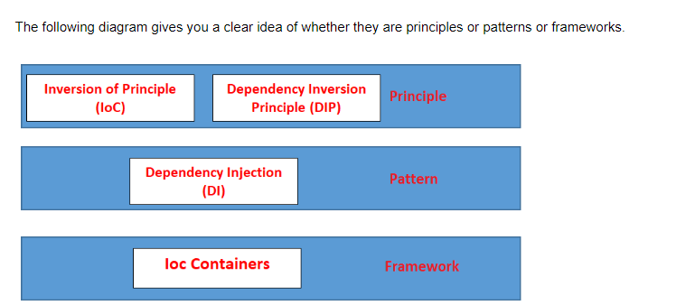

# .net framework and .net core difference

.net core:

# Versions of software’s evolution

## C# Language

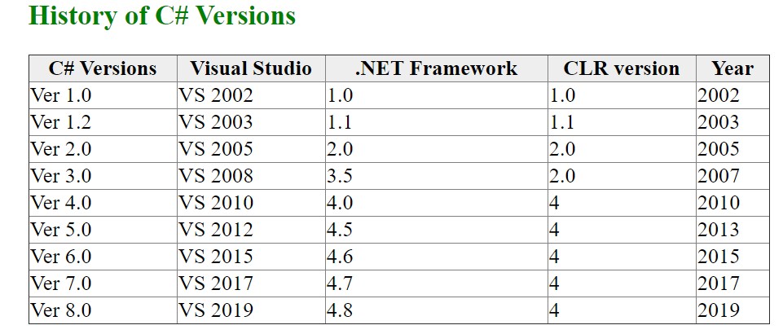

Latest updates on c# Ver 8:

* Readonly members
* Default interface methods
* Pattern matching enhancements:
* Switch expressions
* Property patterns
* Tuple patterns
* Positional patterns
* Using declarations
* Static local functions
* Disposable ref structs
* Nullable reference types
* Asynchronous streams
* Asynchronous disposable
* Indices and ranges
* Null-coalescing assignment
* Unmanaged constructed types
* Stackalloc in nested expressions
* Enhancement of interpolated verbatim strings

## .net framework

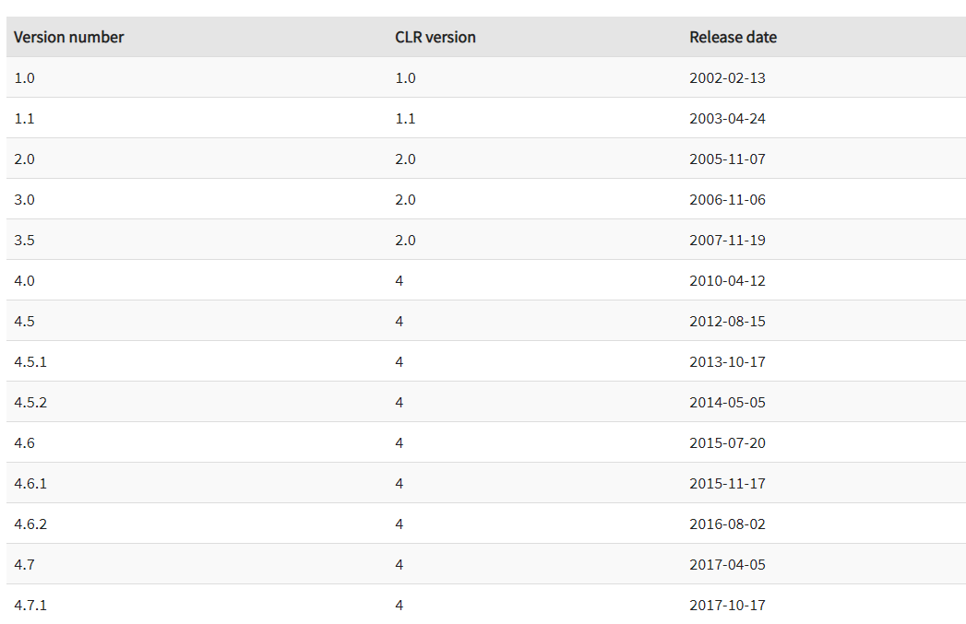

## Asp .net core MVC

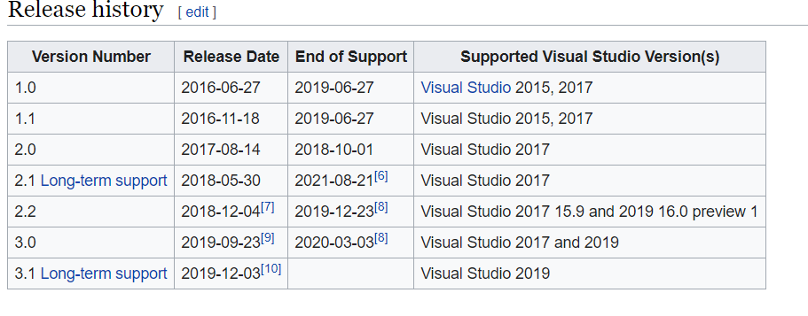

Following are the core features that are provided by the ASP.NET Core

* Built-in supports for [Dependency Injection](https://www.dotnettricks.com/learn/dependencyinjection)
* Built-in supports for the logging framework and it can be extensible
* Introduced new, fast and cross-platform web server - Kestrel. So, a web application can run without IIS, Apache, and Nginx.
* Multiple hosting ways are supported
* It supports modularity, so the developer needs to include the module required by the application. However, [.NET Core framework is also providing the meta package that includes the libraries](https://www.dotnettricks.com/learn/netcore)
* Command-line supports to create, build and run the application
* There is no web.config file. We can store the custom configuration into an appsettings.json file
* There is no Global.asax file. We can now register and use the services into startup class
* It has good support for asynchronous programming
* Support WebSocket and SignalR
* Provide protection against CSRF (Cross-Site Request Forgery)

Nuget package: Is package management tool.

Uses power shell commands.

Benefits ;

* Better performance
* Secured application
* Improved and reduced servicing
* Lightweight

What is scaffolding in MVC

* The term "Scaffolding" is used by many software technologies to mean "quickly generating a basic outline of your software that you can then edit and customize". Here in MVC 3 the scaffolding feature provides us autogenerated Views, Controllers, Database, Table script and so on. All those layers are generated based on the provided model. The fields which need to be shown / hide in the view can be controlled by the [ScaffoldColumn] attribute. It only gives us the basic layout. With that basic layout we can customize our app. Instead of starting our application development from scratch, it gives us some deliverables with which we can design our application.

## MVC

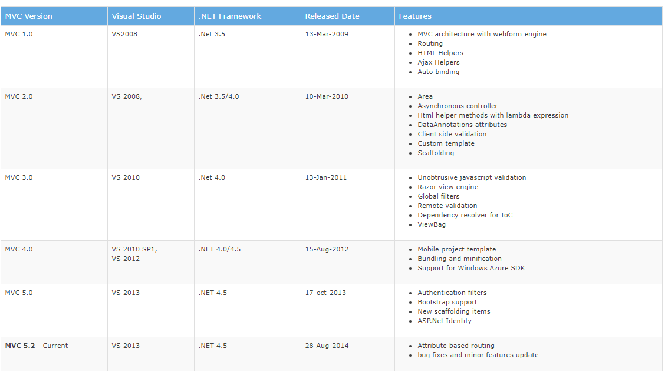

## Entity Framework

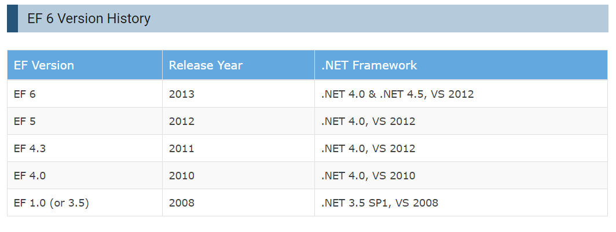

EF Core Versions

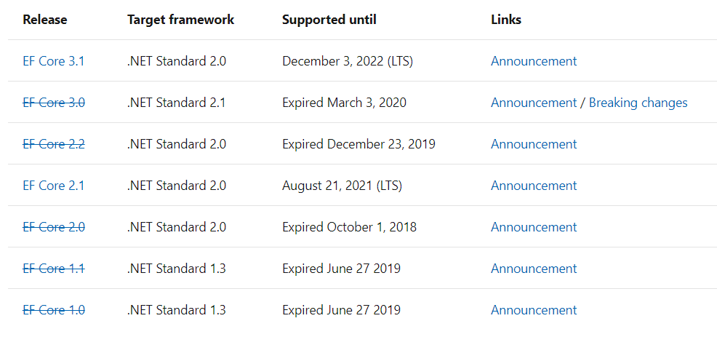

In ASP.NET Core the configuration system is very flexible, and the connection string could be stored in appsettings.json

Important commands:

This will install .net EF, if already exists shows the message. “Tool 'dotnet-ef' is already installed.”

dotnet tool install --global dotnet-ef

dotnet ef migrations

Gives information on add/list/remove migrations.

Note: we can remove a migration only if it had not been applied to DB.

## Angular

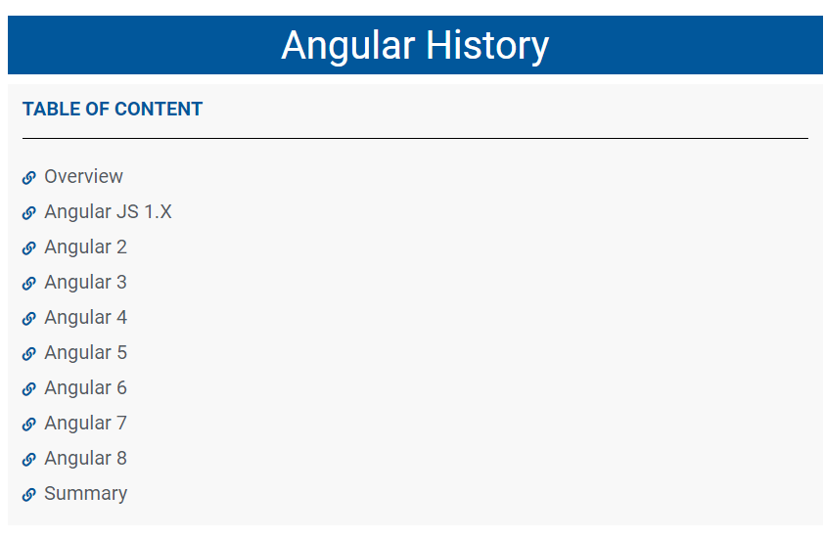

# Life cycle of ASP .net MVC application:

Request lifecycle:

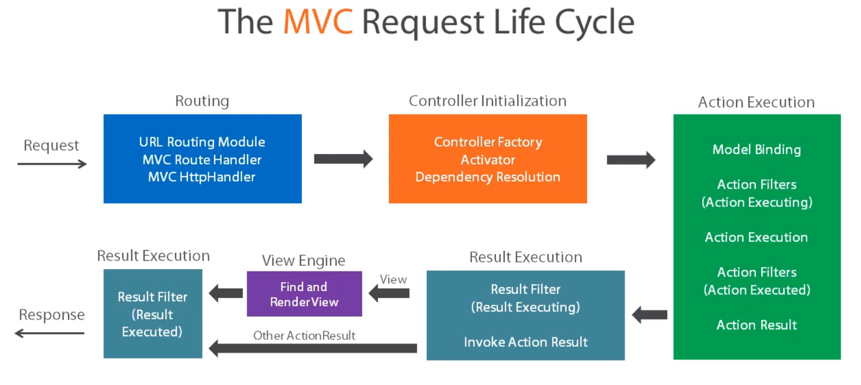

Difference between Web Forms and MVC life cycle:

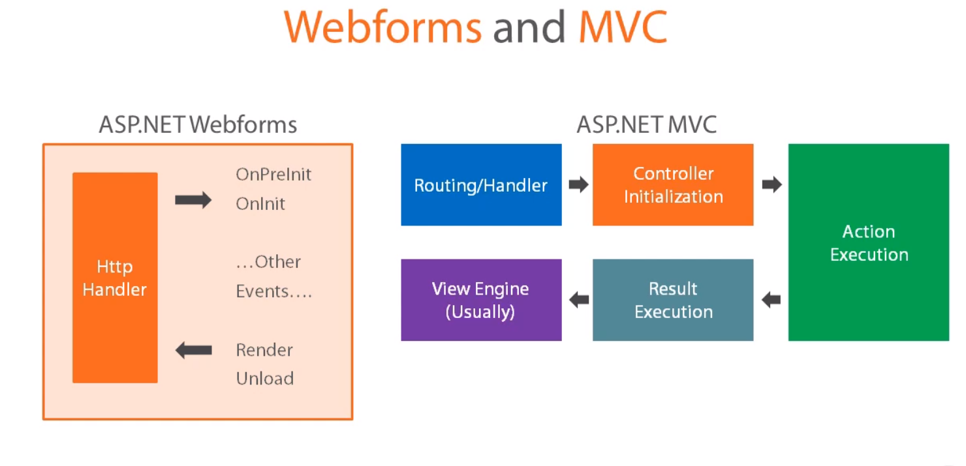

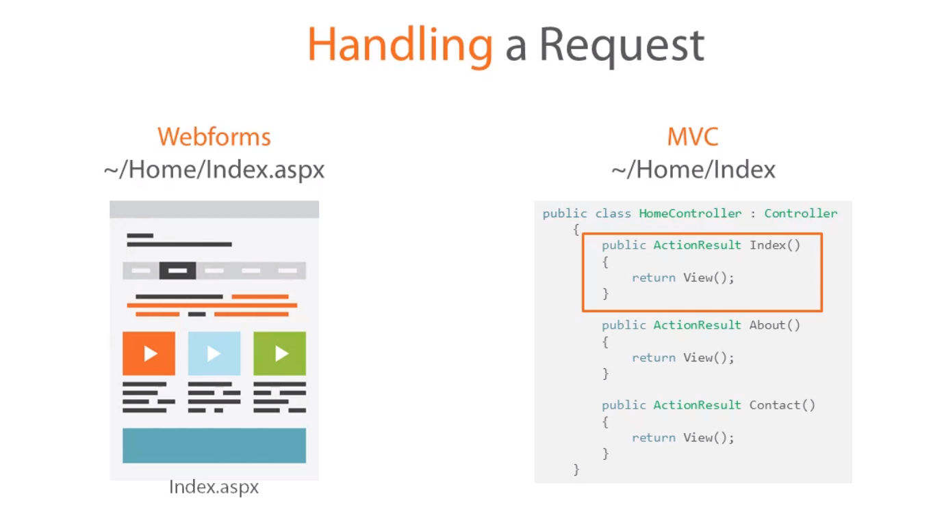

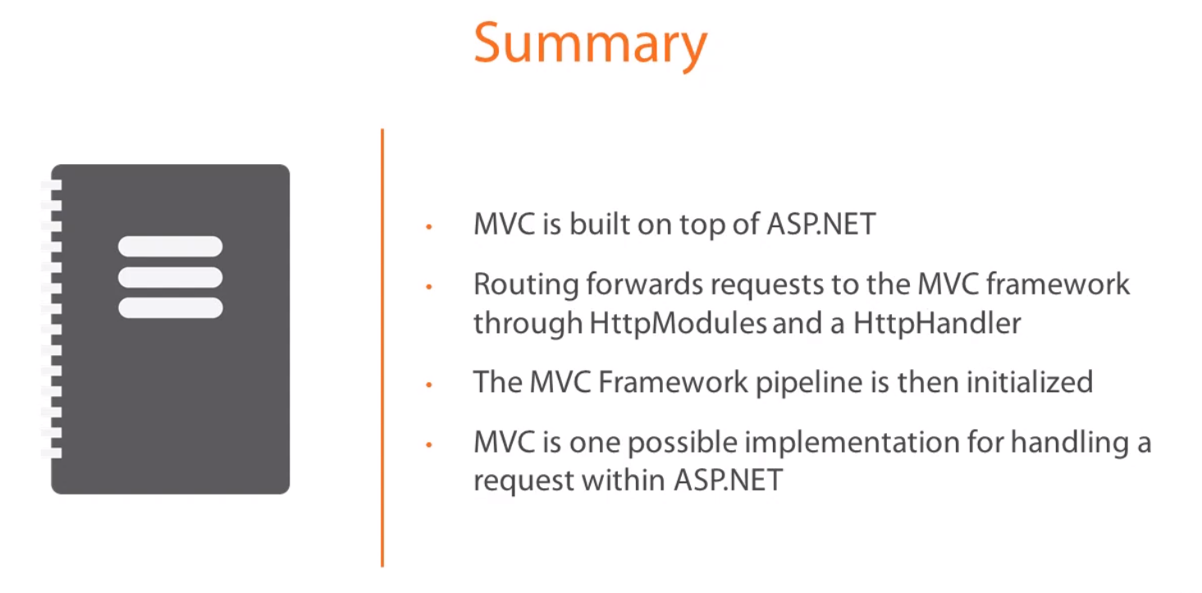

Detailing life cycle of MVC:

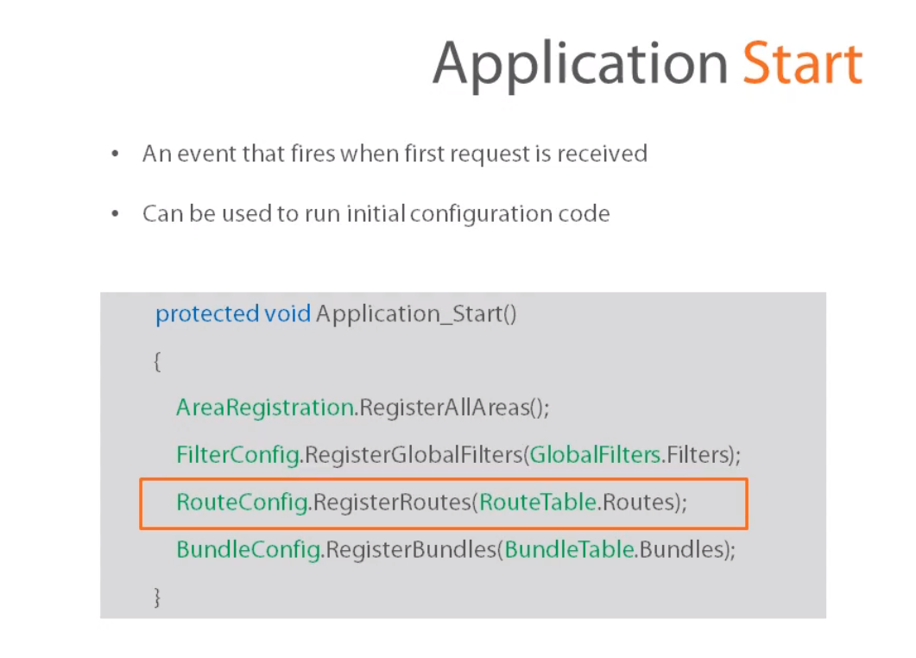

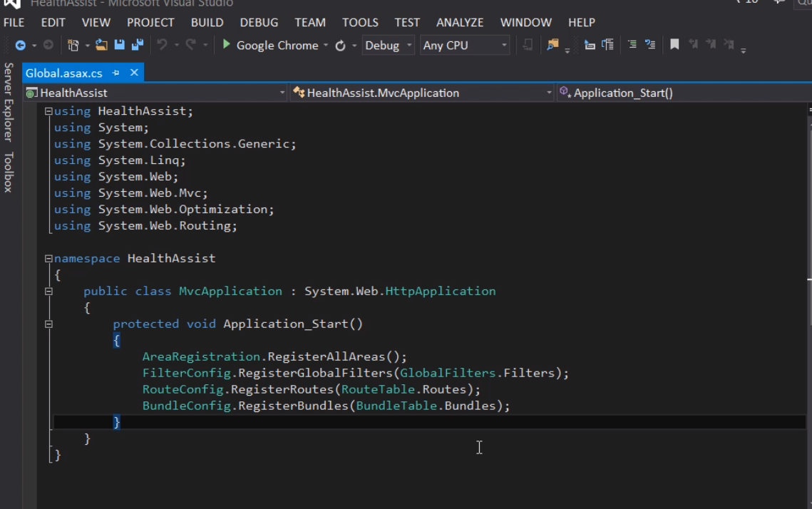

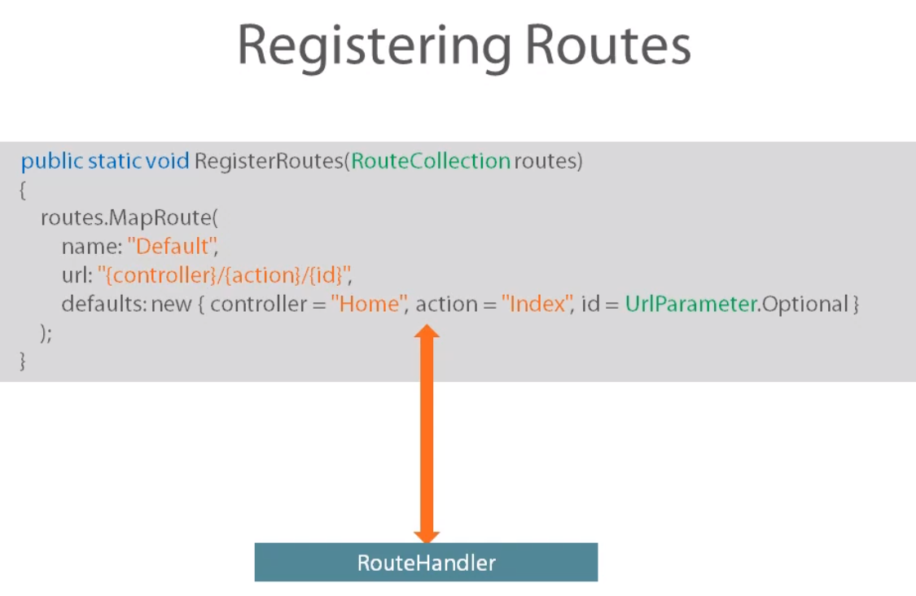

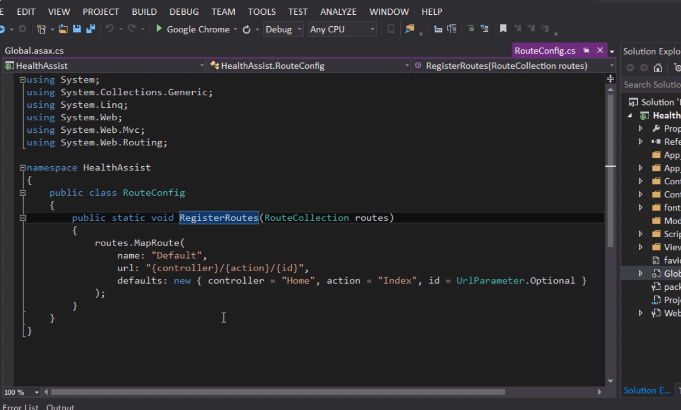

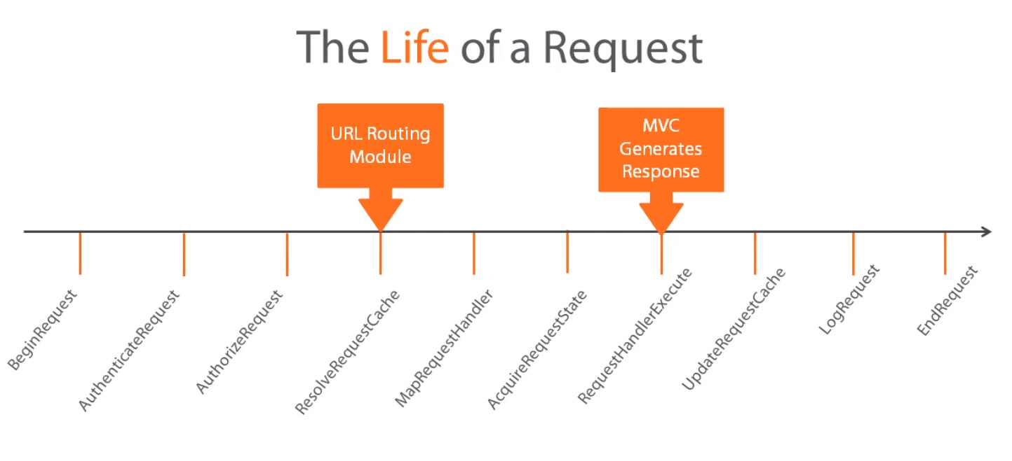

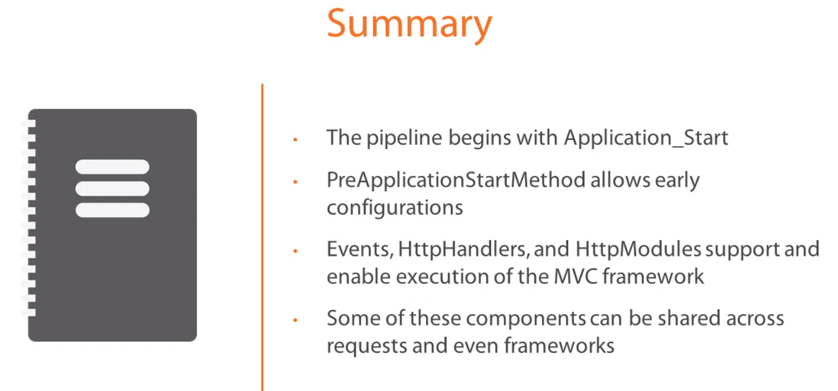

# Life cycle of ASP .net Core application:

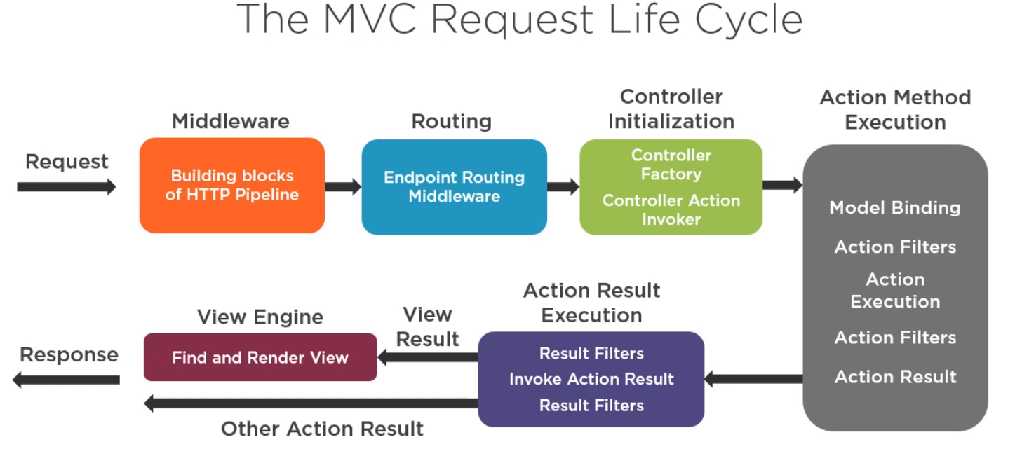

**Middleware:(All in Configure() in startup.cs class)**

* The series of components that form the application request pipeline.
* Features provided like: Routing, CORS, Session, Authentication, Caching.
* The order in which registered is important.

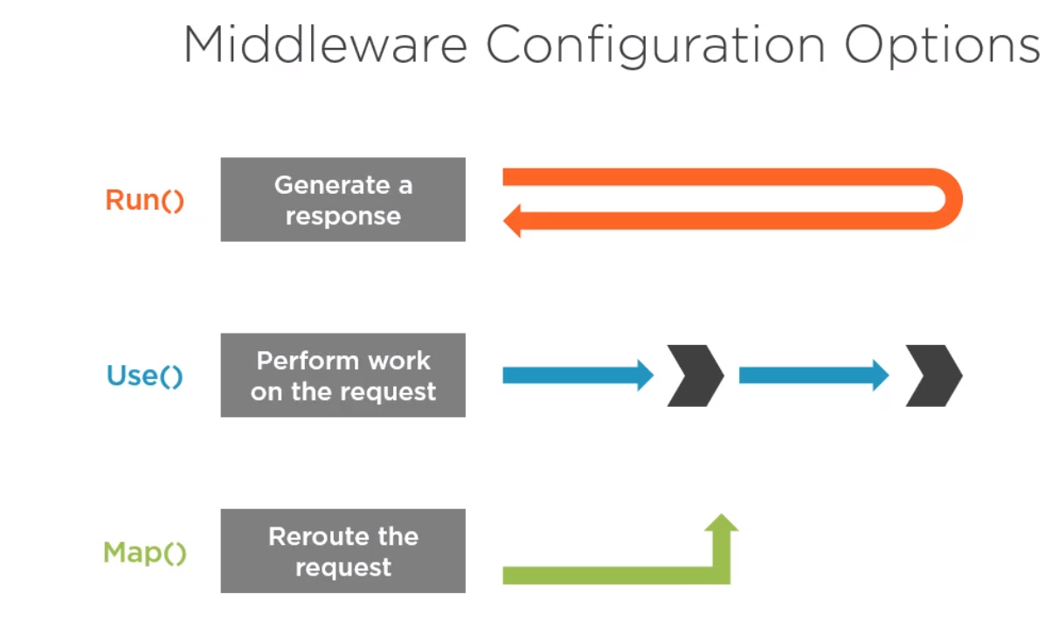

* Use() is the most common one.
* The Run method short circuits the pipeline (that is, it will not call a next request delegate). Thus, Run should only be called at the end of your pipeline.

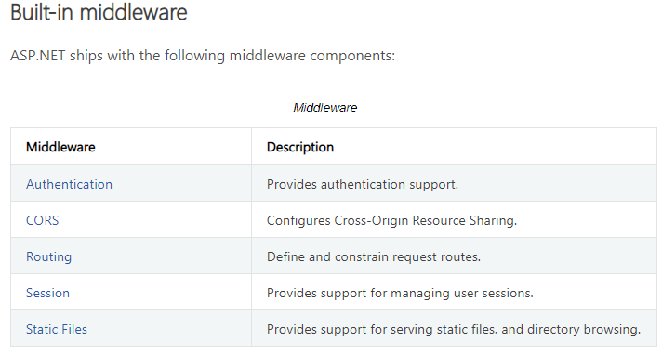

Coding Middleware:

Run and Use:

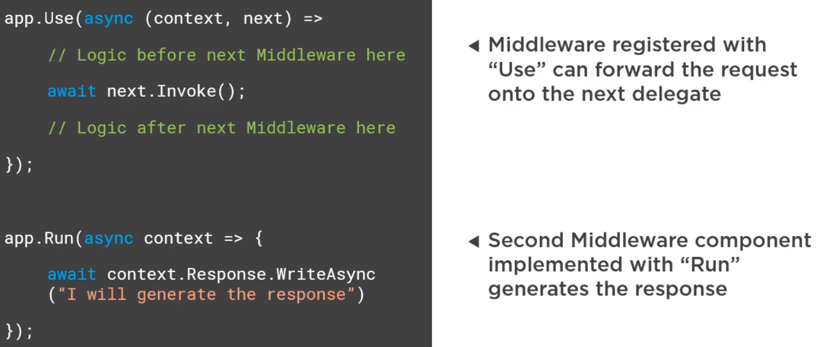

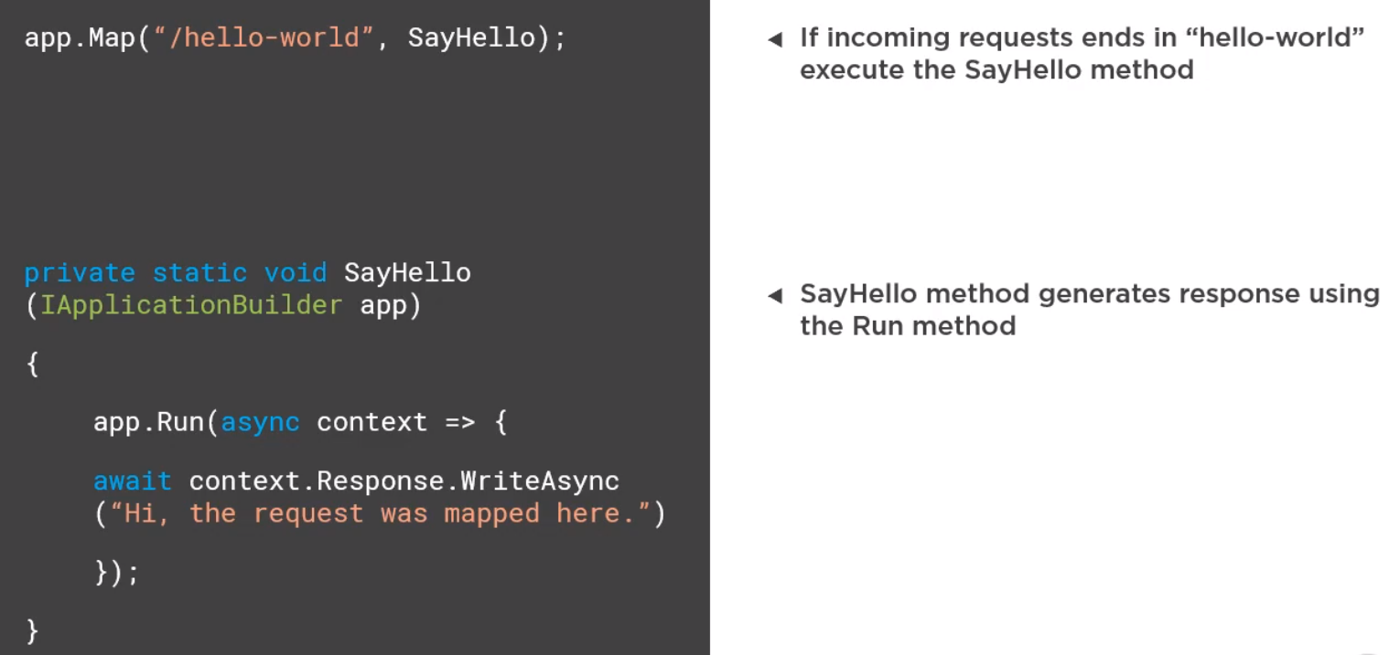

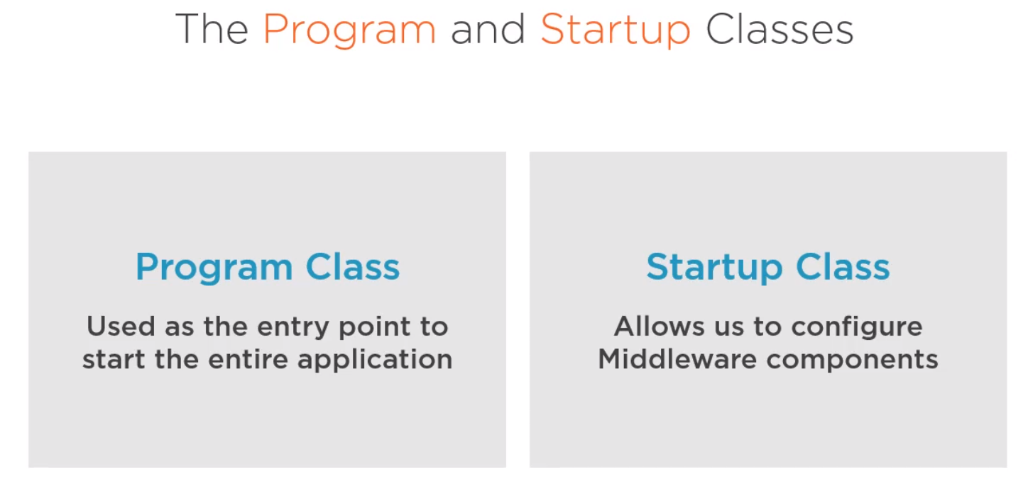

* Configure() in startup.cs class is the method that establishes the core httpMethods by registering middleware components.

Exploring middle ware pipeline: (Calling to a separate class) - This is the same technique used by core components.

Step 1:

Create a class name : FeatureSwitchMiddleware.cs

Step2: Constructor.

Private readonly RequestDelegate nextValue

Public FeatureSwitchMiddleware(RequestDelegate next)

{

nextValue = next;

}

Step3:

Public async Task Invoke(HttpContext httpContext, Iconfiguration config)

{

If(httpContext.Request.Path.Value.Contains(“/features”))

{

Var switches = config.GetSection(“FeatureSwitches”);

Var report = switches.GetChildren().select(x=> ${x.key}:{x.value});

Await httpContext.Response.WriteAsync(string.Join(“\n”,report));

}

else

{

await nextValue(httpContext);  
}

}

Step 4:

Add instance of above class in startUp.

Public void Configure(IApplicationBuilder app)

{

app.UseMiddleware< FeatureSwitchMiddleware > ();  
}

The core middle ware component uses the similar technique, but is hidden in extension method.

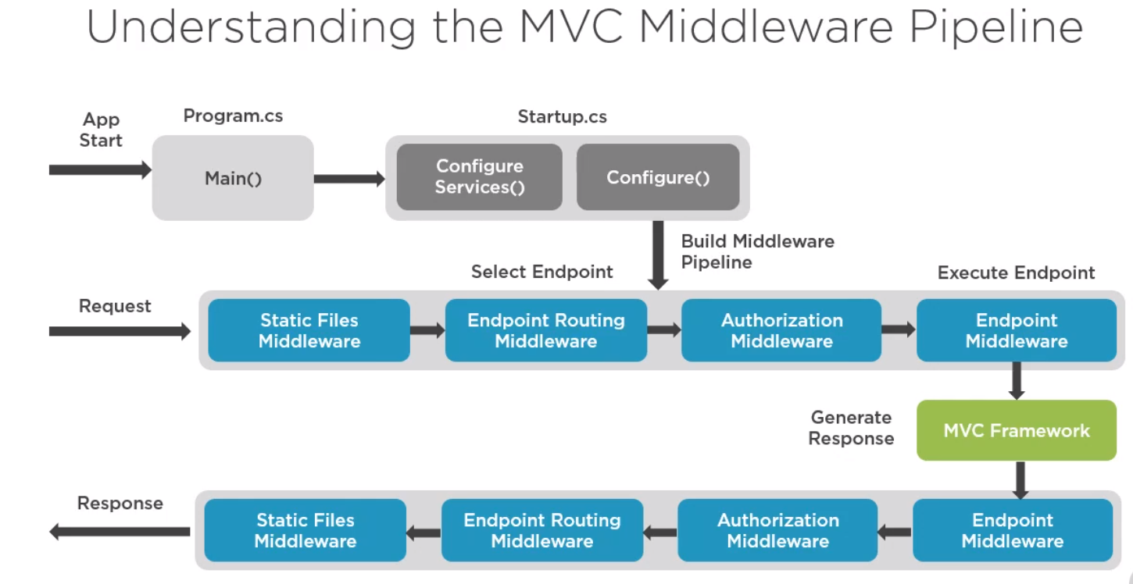

Every request goes through this middleware steps. (Unlike other config setting).

Use of MiddleWare: (Summary) – 6 points to take into consideration.

1. Middleware forms the basic building block of the HTTP pipeline in MVC core.
2. Middleware can perform work on a request in the pipeline or generate a response.
3. Middleware can exists as a simple inline methods or complex, reusable classes.
4. Middleware provides application level features like serving files or authorization.
5. Middleware pipeline in build inside Configure() of startup class.
6. Enpoint routing in .net core 3 is implemented through middleware.

**ROUTING**: (Second high level step in request life cycle).

* .net core changed routing with previous version by introducing End **Point routing.**

Routing is the process of mapping an incoming request to an endpoint.

Types of routing:

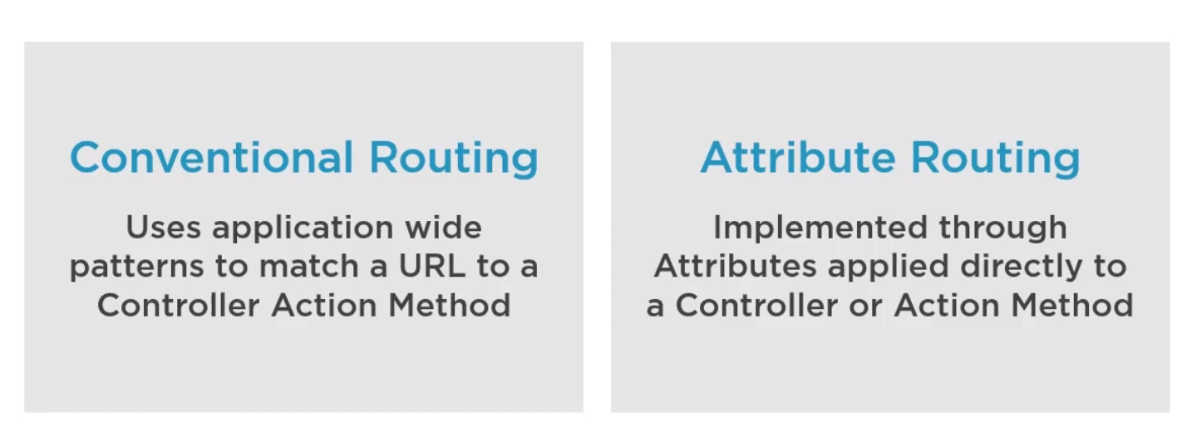

Conventional routing applied to startup class and consumed by Routing Middleware

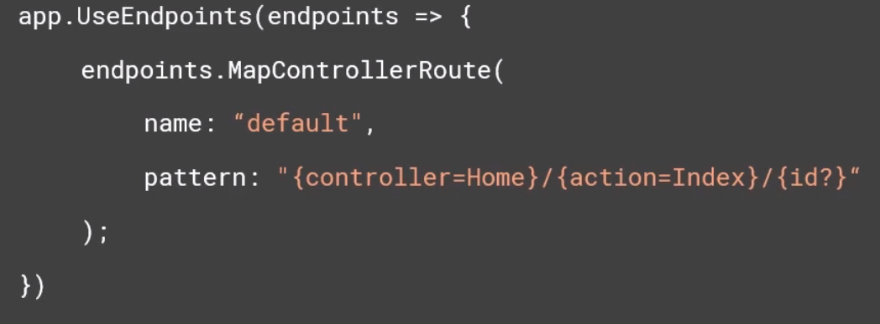

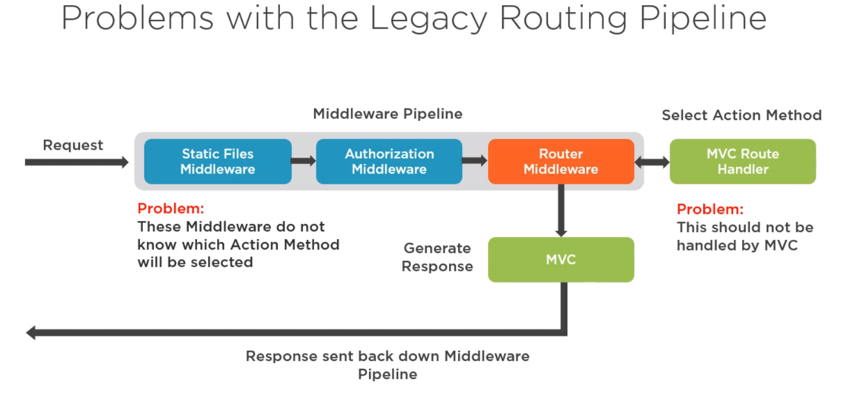

This problem resulted in creation of two middleware for .net core 3:

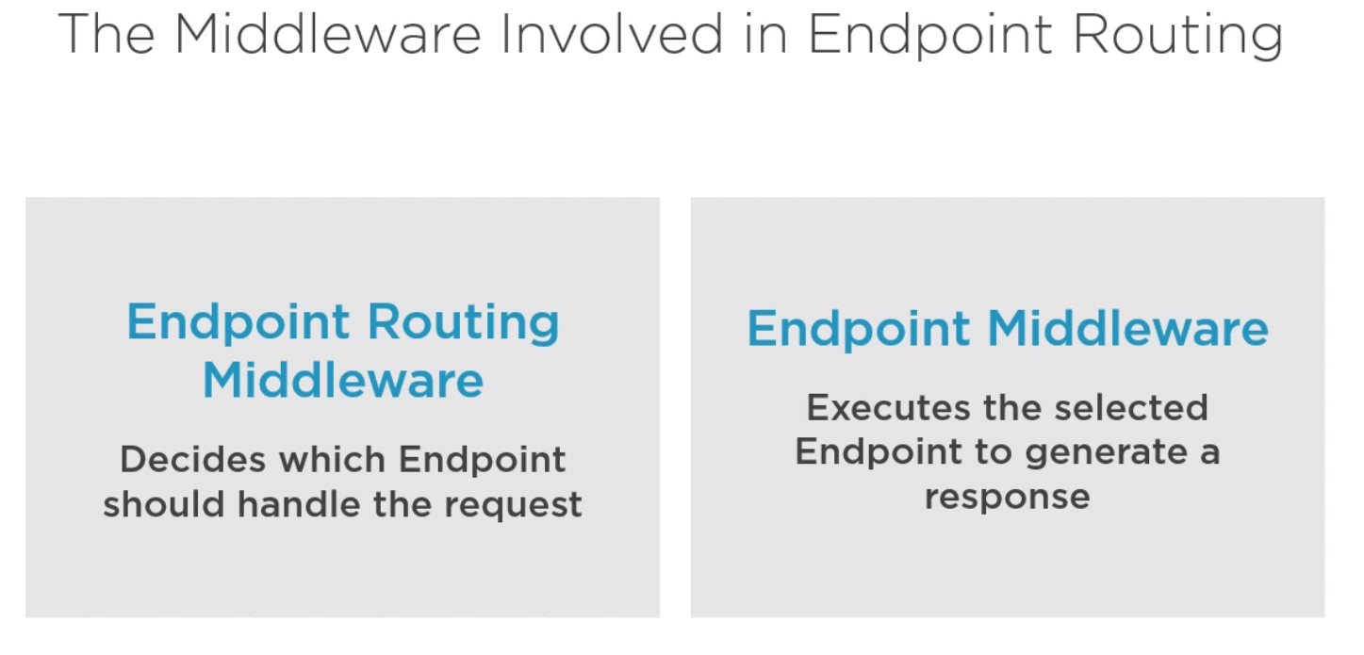

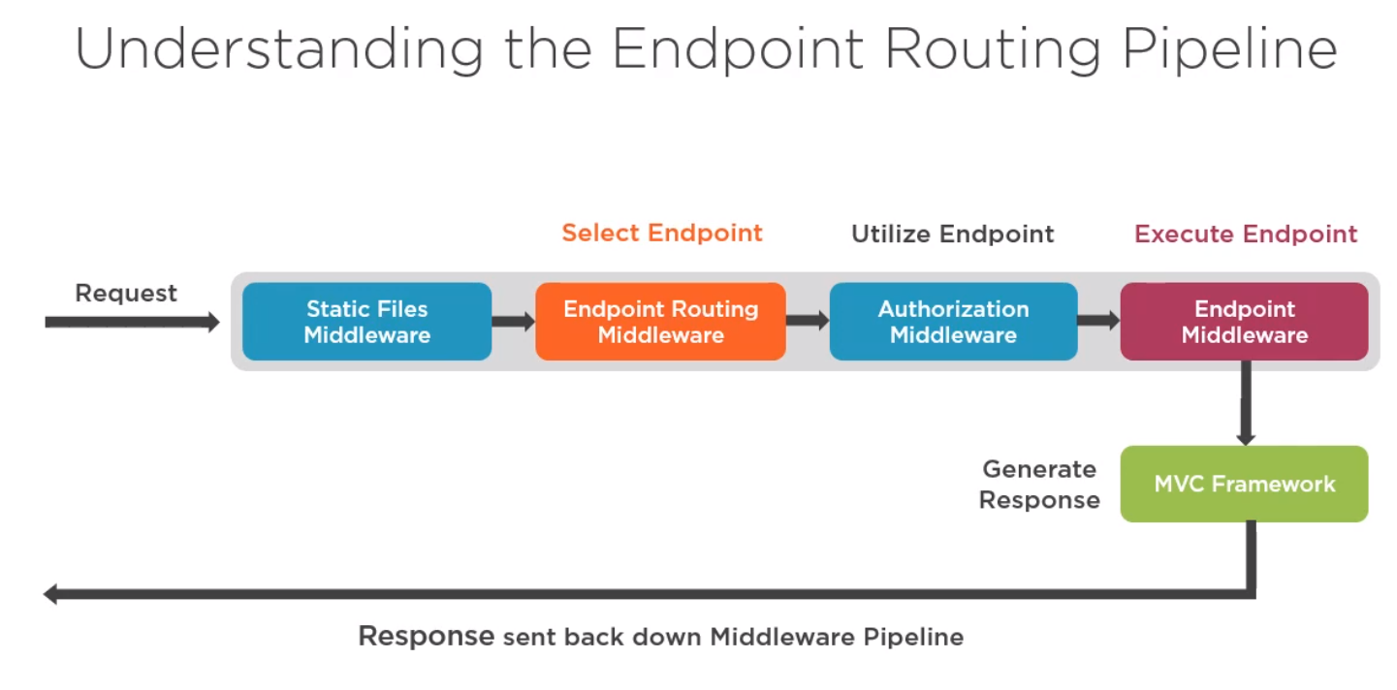

Exploring middleware routing:

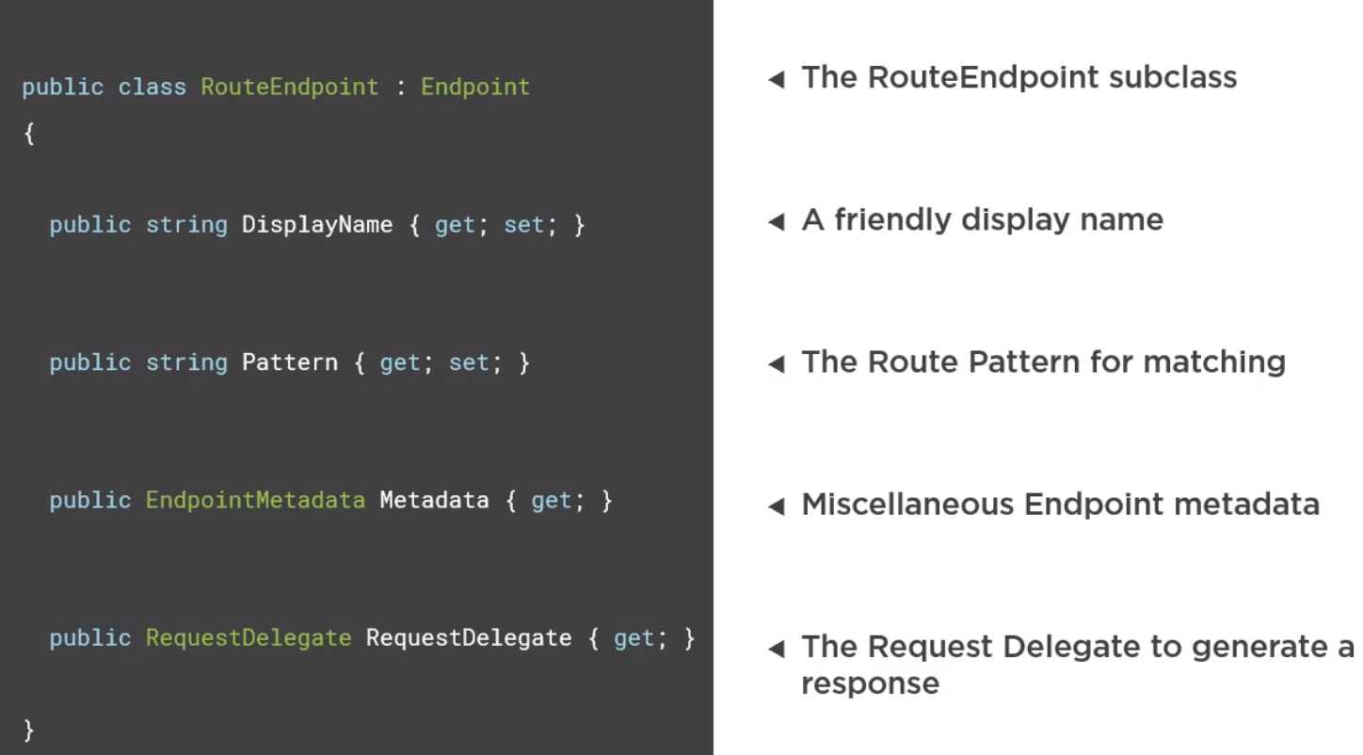

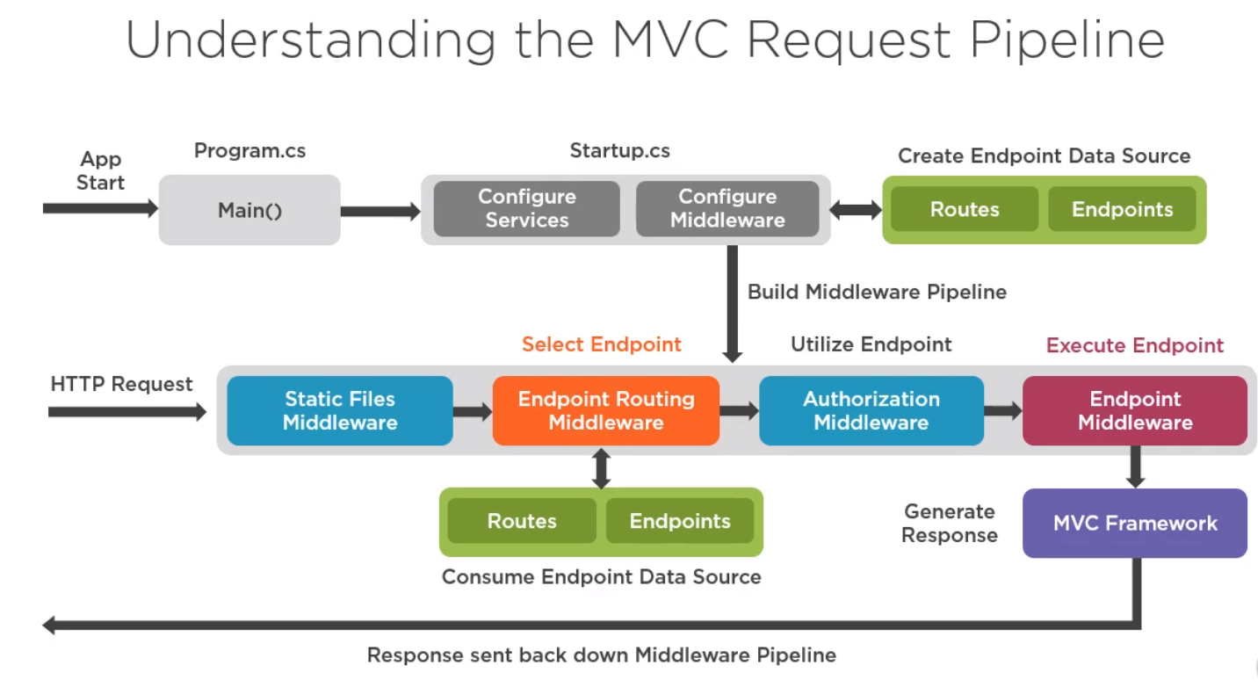

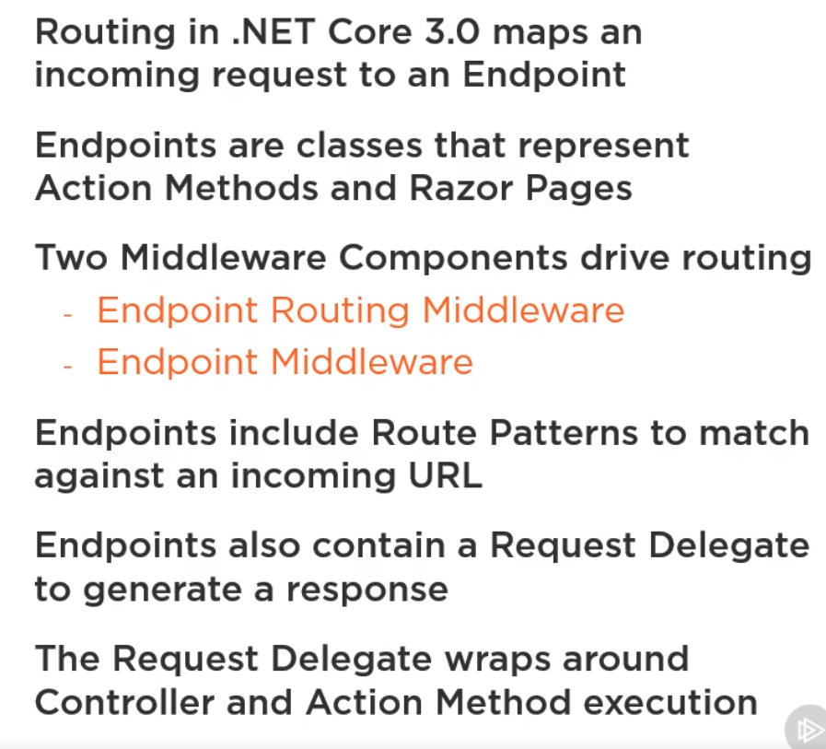

**Controller Invocation:**

**Filter Execution:**

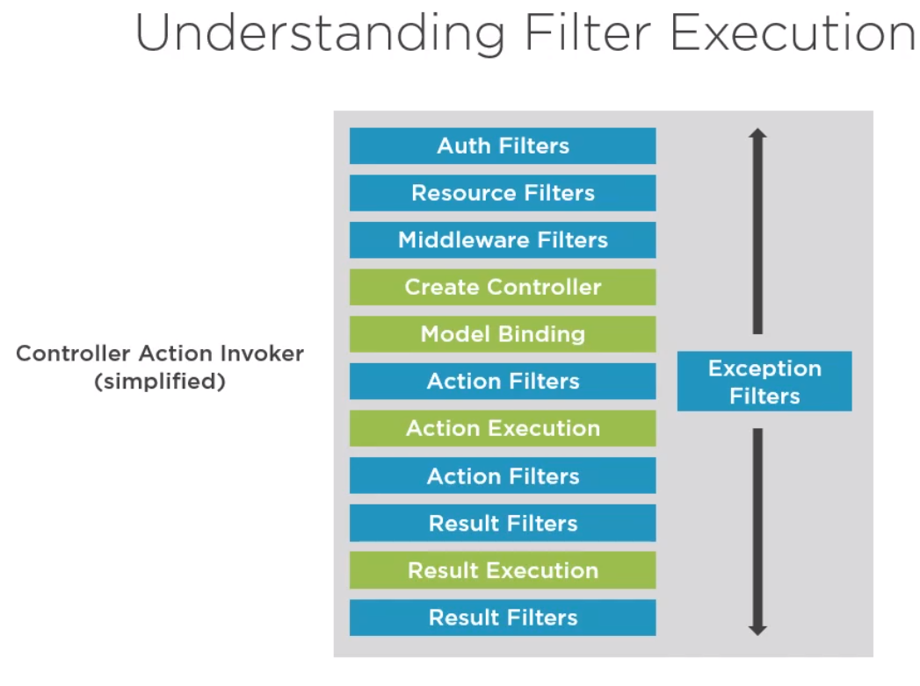

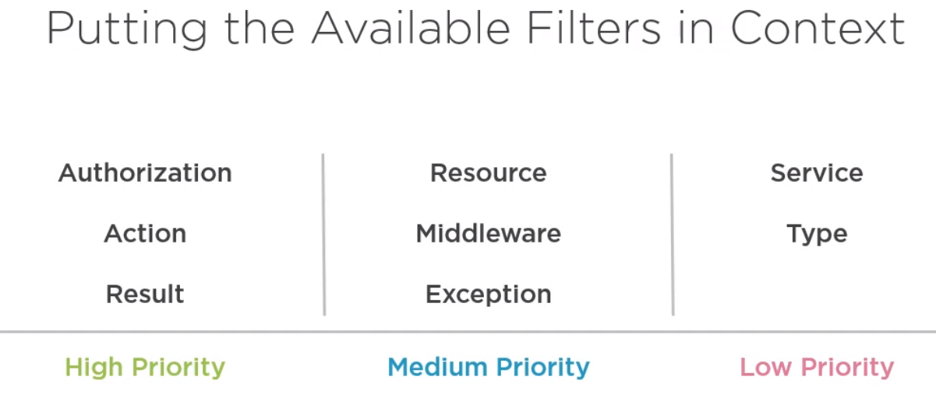

Authorization filter:

* Execute first in the MVC pipeline to determine whether a request is authorized to proceed.
* Uses the IAuthorizationFilter Interface (OnAuthorization is the method of this interface).

Resource Filter: (Called two times)

- Resource filter executes after Authorization filter and last opportunity before the response goes out.

* Uses the interface IResourceFiler(OnResourceExecuting and OnResourceExecuted are the 2 methods inside it).

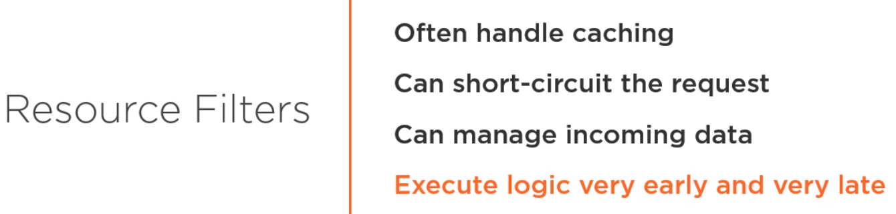

MiddleWare Filter:

* They don’t use any interface. (Use an attribute)
* Is useful reuse or delay middleware logic
* Run middleware within MVC context.

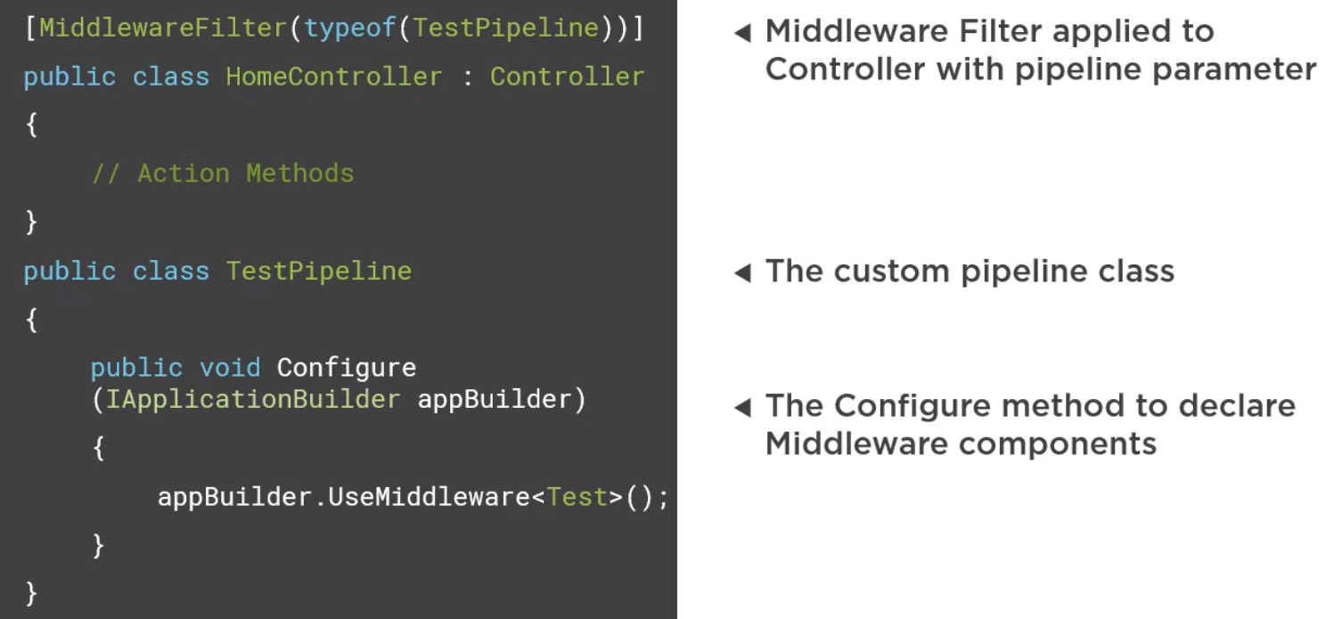

Summary of controller initiation and Filter:

1. The endpoint request delegated executes the controller action invoker.
2. The controller action invoker inherits from abstract resource invoker.
3. These invokers orchestrate the MVC pipeline
4. Authorization filters executes first in the MVC pipeline
5. Resource filters execute logic at start and end of the MVC pipeline.
6. Middleware filters allow us to execute middleware in the context of MVC
7. A controller instance is retrieved using the Controller factory.

**Action method execution:**

* Model binding process.

Action filter:

* Implements IActionFilter interface.
* OnActionExecuting() before Action method.
* OnActionExecuted() after Action method.

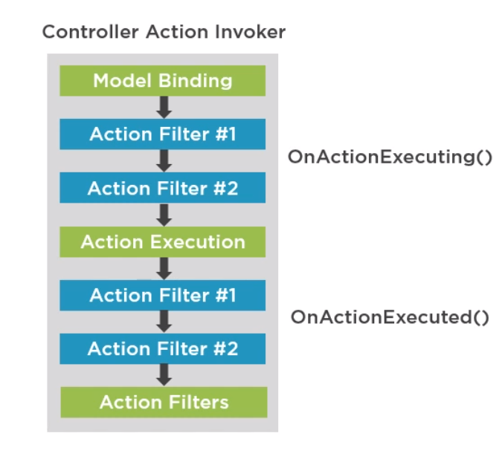

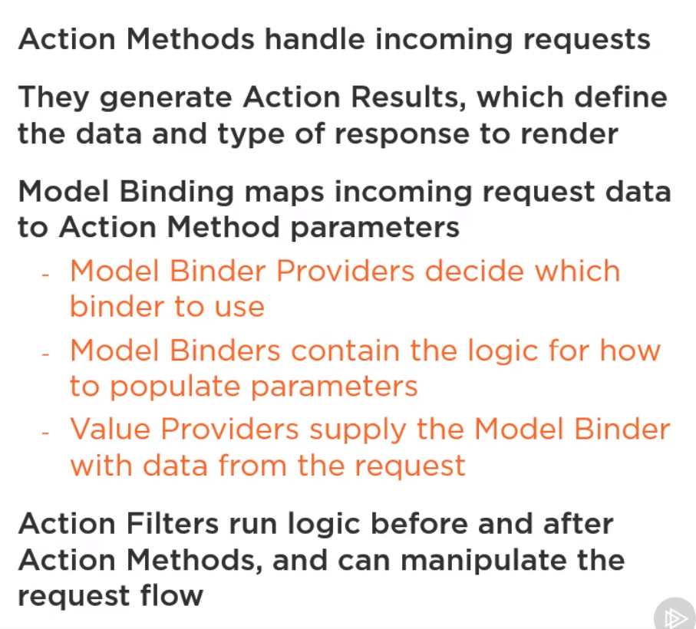

**Action Result:**

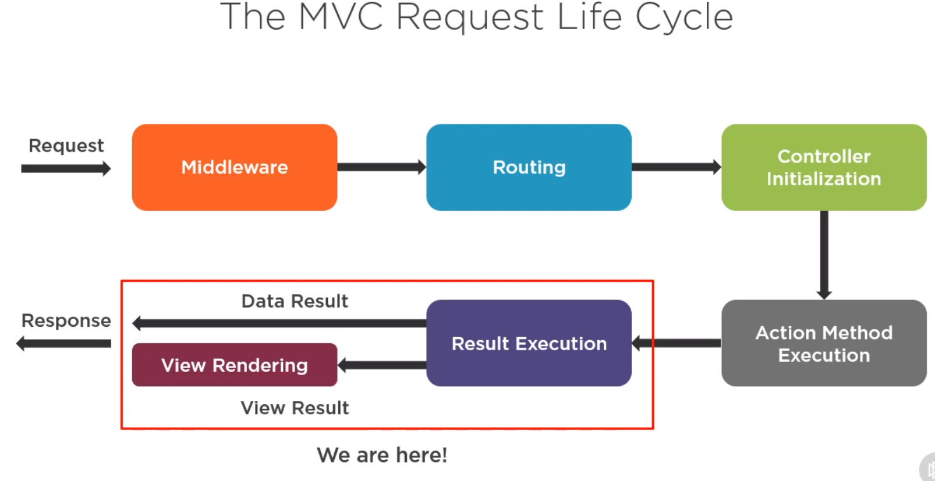

**Two parts:**

* Data driven (Json output)
* View

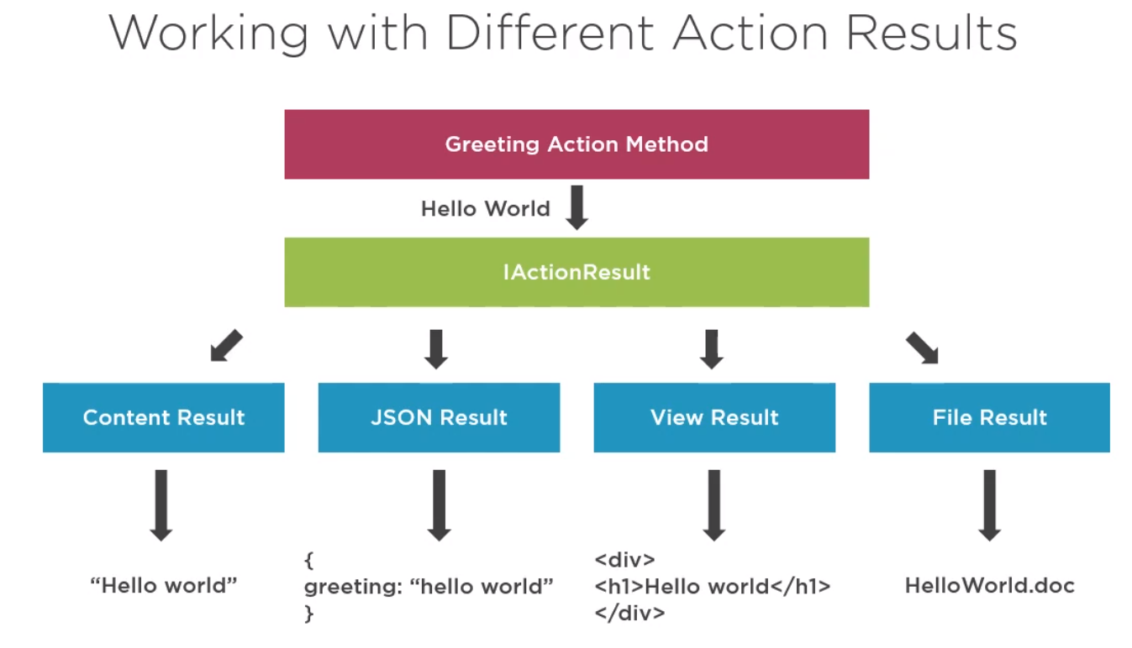

Result Filters: Runs logic before and after an action result executes.

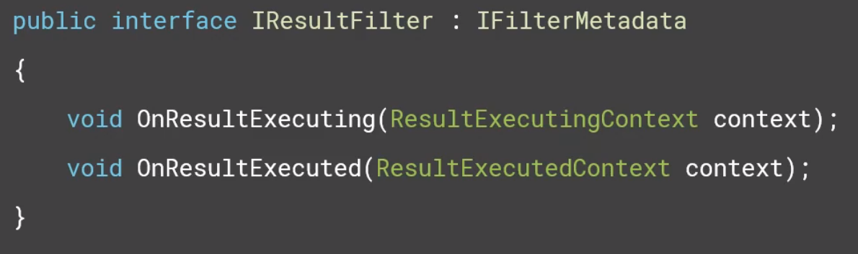

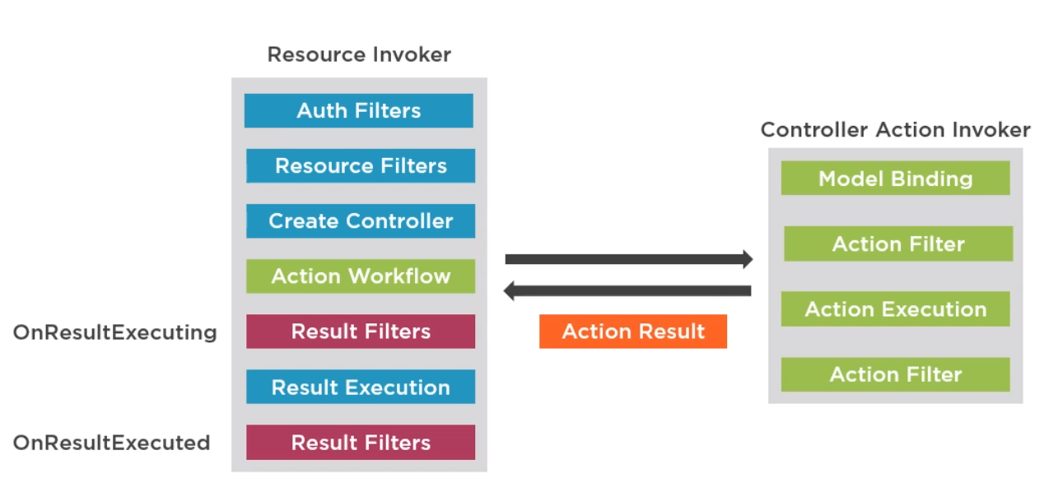

* Action Results are created by Action Methods and executed by the resource invoker logic.
* Action results render the response data back to the client in different formats.
* Result filter is the last place to inject logic before response get back to browser.

View results trigger the razor view engine rendering process:

* The view engine is responsible for locating a view to render
* The view engine result communicates the result of that search
* The view renders markup to the response.

# Latest C# features:

## Async and Await calls

Asynchronous is when work is being executed on a different thread and does not impact the main thread of the application.

The main reason for asynchronous principle is to improve experience for users to relieving the work from current thread mostly UI thread.

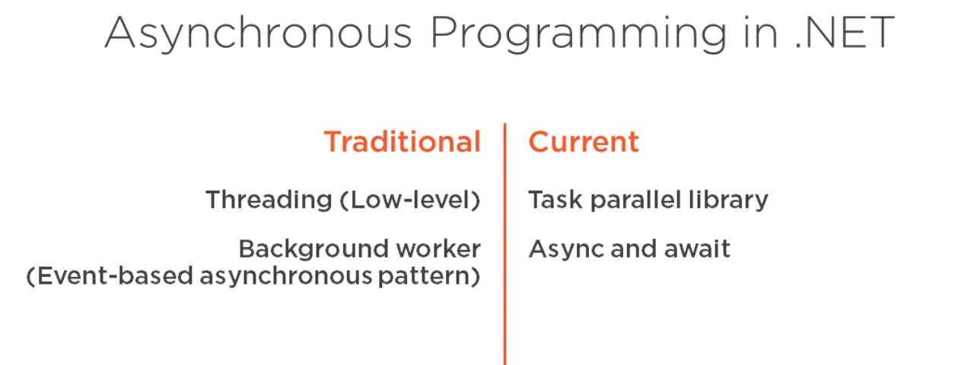

## Tuple

## Pattern matching.

# C# features

## Collection

## Generics

## Delegates

## Dictionary

## List

## Tuple

## Serialization

Serialization is the process of converting the state of an object into a form that can be persisted or transported.

JSON serialization:

using System.Text.Json; using System.Text.Json.Serialization;

string jsonString; jsonString = JsonSerializer.Serialize(weatherForecast);

## Exception Handling in c#

## LINQ (Include and Except) command.

What is the basic structure of a LINQ query?

How is LINQ query syntax translated to C# method calls?

How to express inner and outer joins using LINQ?

Which set manipulation operations are available in LINQ?

How can LINQ query results be aggregated?

How can LINQ query results be grouped?

How can LINQ query results be reused without reevaluating?

When and how is a LINQ query executed and how does this affect performance?

How are lambda expressions used in LINQ queries?

When should my function return IQueryable and when IEnumerable?

# Thread mechanism.

# Queue

# Seri Log

# WebHooks

# Authentication and Authorisation

## - Kerberos for authentication?

## - ID server and IDP

## - Single Sign On. (SSO)

## - OAuth 2 and 1

# Types Of ORM and To use it.

Object Relational Mapper is a mechanism that makes it possible to address, access and manipulate objects without having to consider how those objects relate to their data sources.

Examples are:

* Entity Framework.
* Dapper.
* NHibernate.

# Entity Framework described

Entity Framework is an open source object-relational mapping framework for ADO.NET.

Enables .NET developers to work with a database using .NET objects, and eliminating the need for most of the data-access code they usually need to write.

Usually create my own dbcontext as below:

1 . MyDataContext: DbContext

2. Create contructor of MyDataContext

// Contructor

public ApplicationDataContext(DbContextOptions<ApplicationDataContext> options) : base(options)

{

}

// Add the models created here.

public DbSet<Value> Values { get; set; }

In Imaap:

CrashDbContext : AuditDbContext, this AuditDbContext is a created class.

This AuditDbContext: DbContext

## Entity framework commands used in Command Line.

## Important Nuget packages to be used.

## Fluent API.

## Migration and Seeding data to be handled?

# Publishing done

- Publishing in Nuget package.

## IIS basics and how it is relevant.

## Comparing Kestrel Web Server vs IIS

Kestrel is a cross-platform web server for ASP.NET Core. Kestrel is the web server that's included by default in ASP.NET Core project templates.

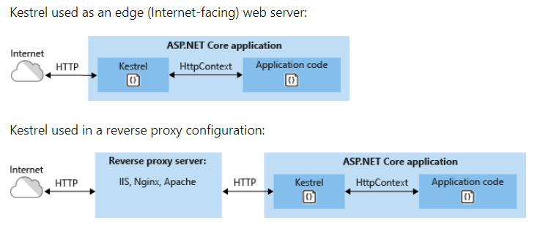

# .net core features explained

## Difference between ConfigureService() and Configure() in startup.cs.

## Exception handling done? Logging mechanism in .net core..

# MVC basics and its version. (Kersetrel)

## Routing in MVC

## Filters in .net

## Exception handling done

# Web Api

## Web API 2 Parameter Binding

Example 1: Sending a simple parameter in the Url

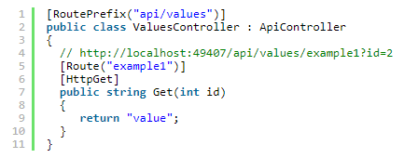

Example 2: Sending simple parameters in the Url

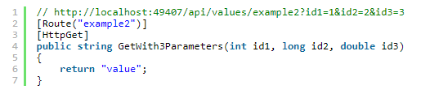

Example 3: Sending simple parameters using attribute routing

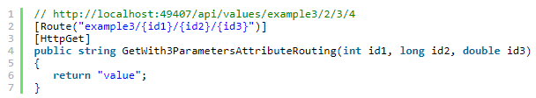

Example 4: Sending an object in the Url

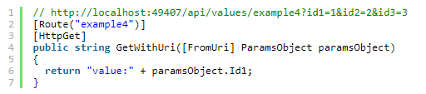

Example 5: Sending an object in the Request body

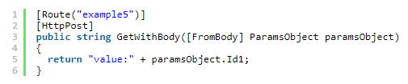

Arrays and Lists

**Example 6:** Sending a simple list in the Url

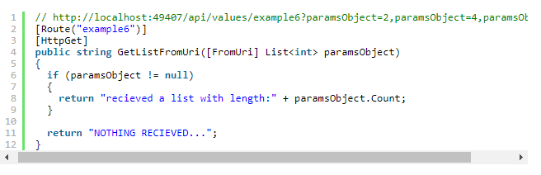

Example 7: Sending an object list in the Body

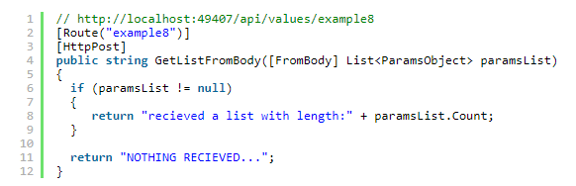

**Example 8:** Sending object lists in the Body

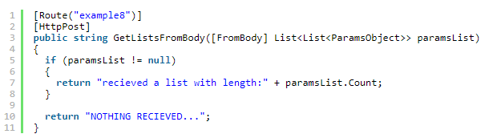

## AutoMapper and Helper class

## Logging mechanism

## Exception Handling done in web api.

## Routing in Web Api.

## Filters in .net

## What is Rest, Web Api and WCF examples.

## API basics.

## Two factor Authentication.

# Compression techniques?

GZIP

# Query String, Query Parameter and URL params.

Typical URL containing a query string is as follows:

<https://example.com/over/there?name=ferret>

URI parameter (Path Param) is basically used to identify a specific resource or resources whereas Query Parameter is used to sort/filter those resources.

# DI lifetime(Transient, Singleton, Scoped and Transient Inside Singleton)

# Performance monitoring tools in VS.

# Notification methods used:

## Rabbit MQ

## Signal R.

# Database

## Postgres SQL interview questions.

## What is NoSQL?

## SqlLite use?

# Devops process

## DevOps practises.

## CI/CD pipelines.

# Tools used for devops

## Jira and Confluence

## CI/CD pipeline

## Cloud

## Azure Architecture Framework

The Azure architecture framework is a set of guiding tenets that can be used to improve the quality of a workload. The framework consists of five pillars of architecture excellence: Cost, DevOps, Resiliency, Scalability, and Security.

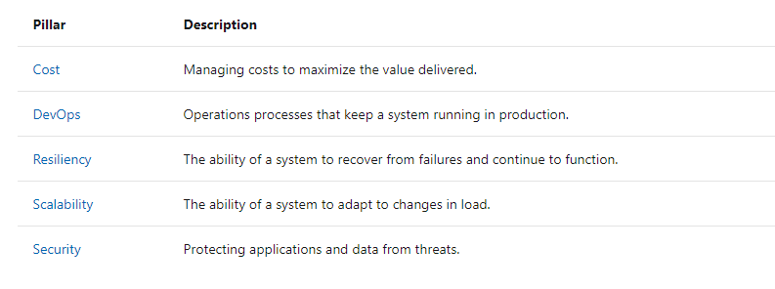

## Azure questions and uses.

## Serverless on Azure

monolithic —> microservices —> serverless architecture (FaaS) is driven by the need for greater agility and scalability.

* Logic apps
* Azure functions

Here’s a few examples of events that can be used to trigger the execution of Functions of code in Serverless architecture:

HTTP / HTTPS Request

Message Queue Trigger

File / Storage Trigger

Timer / Schedule

Common scenarios for Azure Functions are:

Timer-based processing

Azure service event processing

SaaS event processing

Serverless web application architectures

Serverless mobile backends

Real-time stream processing

Real-time bot messaging

## What are the key characteristics exposed by Cloud Computing?

## Azure CLI?

## Azure Fabric?

# What are Storage keys in Azure?

# Explain what is Federation in SQL Azure?

# Why should you use Azure CDN?

# What are the roles available in Windows Azure?

# What is the use of VNET?

# How Many Types Of Deployment Models Are Used In Cloud?

Public cloud

Private cloud

Community cloud

Hybrid cloud

# What is the difference between Public Cloud and Private Cloud?

# Name the web application types that can be deployed with the Azure?

# Types of services offered in cloud /host web sites in Azure ? IAAS, PAAS, SAAS and Serverless.

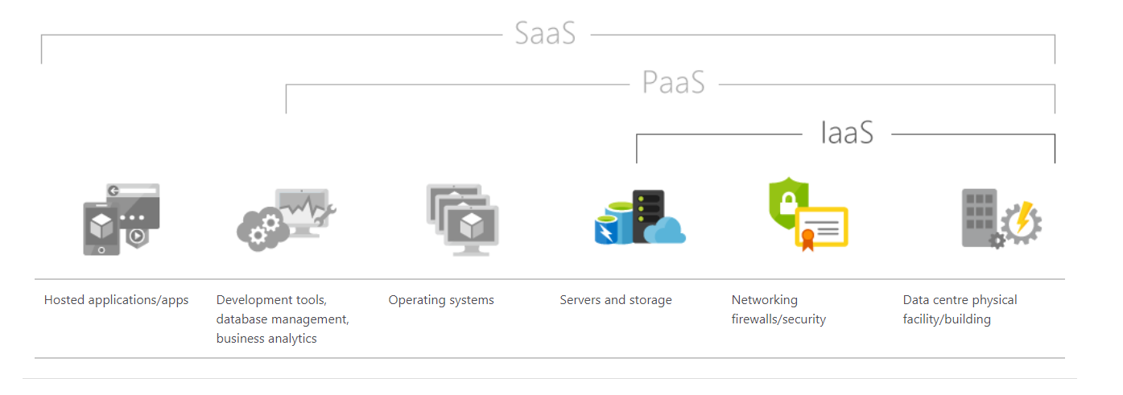

# What is Azure Function?

# Azure diagnostics

# What is Blob?

# What is the difference between Block Blob vs Page Blob?

# Scalability of the cloud computing?

# What are the advantages of cloud computing?

# What are the different cloud deployment models?

# Azure Active Directory in cloud, AD(Azure Directory) - In premise.

# AAD, B2B and B2C login.

# Terms to handle

## Container

## Dockerizing

## Yaml

## PowerShell

## ArmTemplates

## Web Hooks

# Microservices.

# Using cloud watch and Azure monitor

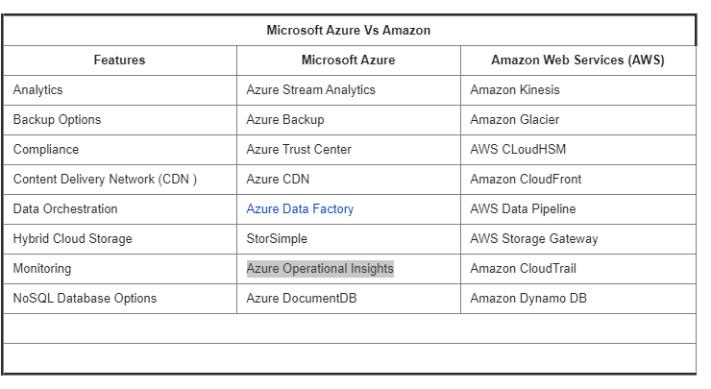

# What are the important drawbacks of using Microsoft Azure?

* Azure needs to be expertly managed and maintained, which includes patching and server monitoring.
* Speed is a definite issue if there isn’t a close region. (If you live in South America, however, then you only have access to one available region, which is designated as “Brazil South.” Africa has two announced regions, but nothing active as of yet.) (However, like AWS not all advertised services are available in every country.)
* Difficult Migration: Migration from competitors to Azure can be complex. Azure itself provides tools within Azure Migrate to help with migration. This makes migration to Azure easier than it would be moving from Azure to another competitor.

# Common Web techniques

## CORS (Cross-origin resource sharing)

* Browser security prevents a web page from making requests to a different domain than the one that served the web page. This restriction is called the same-origin policy.
* Two URLs have the same origin if they have identical schemes, hosts, and ports (RFC 6454).
* These two URLs have the same origin:
* https://example.com/foo.html
* https://example.com/bar.html

These URLs have different origins than the previous two URLs:

* https://example.net: Different domain
* https://www.example.com/foo.html: Different subdomain
* http://example.com/foo.html: Different scheme
* https://example.com:9000/foo.html: Different port

A request for a resource (like an image or a font) outside of the origin is known as a cross-origin request. CORS (cross-origin resource sharing) manages cross-origin requests.

In .net core 3 ways:

1. In middleware using a named policy or default policy. (Configure() in Startup.cs)

2. Using endpoint routing.

3. With the [EnableCors] attribute.

## SSL certifcate.

## Wildcard SSL cert for trlsoftware.com, we have certs for individual subdomains via LetsEncrypt.

## What is multi tenancy and how is it achieved?

## How to make a site Https?

## Nginx, Proxy and Reverse proxy.

## Error Codes in server and client side?

HTTP response status codes indicate whether a specific HTTP request has been successfully completed. Responses are grouped in five classes:

1 Informational response (100–199),

2 Successful responses (200–299),

3 Redirects (300–399),

4 Client errors (400–499),

5 Server errors (500–599).

## Globalisation and localisation

## JSON serialisation and Deserialization

using System.Text.Json; using System.Text.Json.Serialization;

string jsonString; jsonString = JsonSerializer.Serialize(weatherForecast);

The following example uses synchronous code to create a JSON file:

jsonString = JsonSerializer.Serialize(weatherForecast);

File.WriteAllText(fileName, jsonString);

Deserialise:

wethrForcst= JsonSerializer.Deserialize<WeatherForecastWithPOCOs>(jsonString);

# Using Git Bash and other version control mechanism!

C# questions:

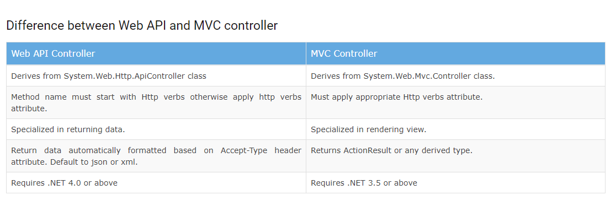

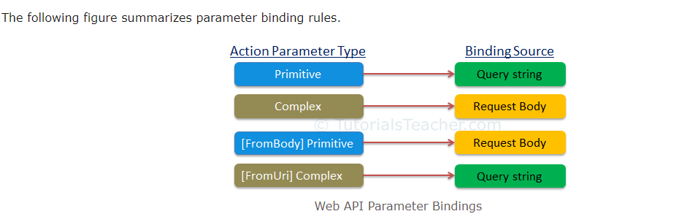

Optional Parameters in Web API Attribute Routing and Default Values: You can make a URI parameter as optional by adding a question mark (“?”) to the route parameter. If you make a route parameter as optional then you must specify a default value by using parameter = value for the method parameter.

Q7. How does the version of .NET and C# affect compatibility?

Q8. What should I know about Garbage Collection in .NET?

Q9. What is the best way to consume third party libraries in .NET?

Q10. What are strong-named assemblies and how do I create them?

Q11. How are value and reference types different?

Q12. What is the difference between classes and structs?

Q13. What is boxing and unboxing?

Q14. Why are nullable types applicable only to value types?

Q15. How are enumeration types supported in C#?

Q16. How can multi-dimensional data be modelled using arrays?

Q17. What are some of the less commonly used C# operators?

Q18. How can method parameters be passed by reference?

Q19. When does using anonymous types make sense?

Q20. What does it mean that C# is a type safe language?

Q21. How can dynamic binding be implemented in C#?

Q22. What is polymorphism and how to implement it in C#?

Q23. What is the meaning of individual accessibility levels?

Q24. What are the advantages and disadvantages of abstract classes over interfaces?

Q25. When should one explicitly implement an interface member?

Q26. What does the 'new' modifier on a method mean?

Q27. How to correctly override the Equals method?

Q28. When and how to overload operators?

Q29. How do delegates and events differ?

Q30. What's special about the IDisposable interface?

Q31. How do finalizers work?

Q32. What is the purpose of static class members?

Q33. When are extension methods useful?

Q34. What are auto-implemented properties and why are they better than public fields?

Q35. What are expression-bodied members?

Q36. When can string interpolation be used instead of string formatting?

Q37. How do locale settings affect string manipulation?

Q38. When can string manipulation performance suffer and how to avoid it?

Q39. How can Generics improve code?

Q40. How to implement a generic method or class?

Q41. What are generic type constraints?

Q42. How does the compiler handle the IEnumerable interface?

Q43. What is covariance and contravariance?

Q44. How to implement a method returning an IEnumerable?

Q45. What advantages do collection classes have over arrays?

Q46. Why are there so many collection classes and which one should I use?

Q47. What problem do concurrent collections solve?

The .NET Framework 4 brought the System.Collections.Concurrent namespace. This has several collection classes that are **thread-safe and scalable**. These collections are called concurrent collections because they can be accessed by multiple threads at a time.

1 ConcurrentStack<T> 2 ConcurrentQueue<T> 3 BlockingCollection<T> 4 ConcurrentBag<T> 5 ConcurrentDictionary<TKey,T>

Q48. How are immutable collections different from other collections?

Q49. What is the basic structure of a LINQ query?

Q50. How is LINQ query syntax translated to C# method calls?

Q51. How to express inner and outer joins using LINQ?

Q52. Which set manipulation operations are available in LINQ?

Q53. How can LINQ query results be aggregated?

Q54. How can LINQ query results be grouped?

Q55. How can LINQ query results be reused without reevaluating?

Q56. When and how is a LINQ query executed and how does this affect performance?

Q57. How are lambda expressions used in LINQ queries?

Q58. When should my function return IQueryable and when IEnumerable?

Q59. What are the differences between concurrent, multithreaded and asynchronous programming?

Q60. Which Timer class should I use and when?

Q61. How to create a new thread and manage its lifetime?

Q62. What is a critical section and how to correctly implement it?

Q63. How to manage multiple threads in .NET framework?

Q64. What abstractions for multithreaded programming are provided by the .NET framework?

Q65. What is the recommended asynchronous pattern in .NET?

Q66. What is an Asynchronous programming model?

Q67. What is an Event-based asynchronous pattern?

Q68. In what order is code executed when using async and await?

Q69. What is the best way to start using asynchronous methods in existing code?

Q70. What are some of the common pitfalls when using async and await?

Q71. How are exceptions handled in asynchronous code?

Q72. What are the best practices for asynchronous file operations?

Q73. What types of serialization are supported in the .NET framework?

Q74. What is reflection and what makes it possible?

Q75. What are potential dangers of using reflection?

Q76. When to create custom attributes and how to inspect them at runtime?

Q77. How has C# changed since its first version (C# v1.0 to 7.0)?

Q78. How to upgrade older versions of C# code to C# 6.0?

Q79. How did tuple support change with C# 7?

Q80. What are local functions and when can they be useful?

Q81. What is pattern matching and how is it supported in C# 7?

Q82. What is a discard and when can it be used?

Q83. What improvements for asynchronous programming have been introduced in C# 7?

Q84. How was support for passing values by reference expanded in C# 7?

Q85. How to handle Errors in C# (v6, v7)

Q86. What Functional Programming Features are supported in C#

Q87. What are the major new features in C# 8?

Q88. How are .NET Core and .NET Standard evolving?

Q89 What is the use of <T> in c# .net?

Q90 How porting dotnet framework to core done?

Q91 What is Dapper in .NET ?

Q92 Difference between Entity Framework and Entity Framework core?